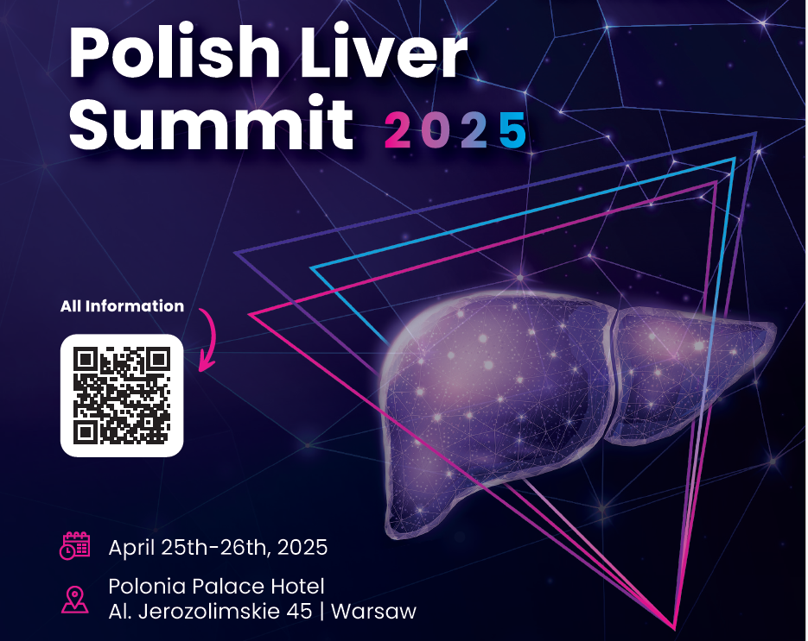
How Far Are We from WHO HCV Elimination 2030 Goals with 10 Years of Revolutionary Treatments?
Conference of Polish Hepatology Experts' Group

25.04.2025
12.00 – 13.40 I OPENING SESSION
- 12.00 – 12.10
Opening and Introduction – Prof. Krzysztof Tomasiewicz, Head of HCV Polish Experts Group
- 12.10 – 12.20
Polish Perspective towards HCV Elimination, Polish Presidency in EU - Izabela Leszczyna, Polish Ministry of Health
- 12.20 - 12.30
Strategic Initiatives for HCV Management at the National Level – Filip Nowak, President of the National Health Fund (NFZ)
- 12.30 - 12.50
Global Status and Poland's National Elimination Profile for HCV - Dr. John Ward, Director, Coalition for Global Hepatitis Elimination
- 12.50 – 13.05
Polish General Practice Screening Status for 2025 – Representative of Polish Society of Family Medicine
- 13.05 – 13.15
Cost Effectiveness of Universal HCV Screening Strategies in Poland - Anna Kowalczuk, Agency for Health Technology Assessment and Tariff System
- 13.15 – 13.25
Role of the Supreme Medical Chamber in HCV Elimination - Łukasz Jankowski, Head of Supreme Medical Chamber in Poland
- 13.25 – 13.40
Decade of Revolutionary HCV Treatment & Importance of Short Treatment Duration – Prof. Robert Flisiak
13.40 – 13.55 Coffee Break

13:55 – 15:55 II SESSION: Key Learnings on National Screening Programs in EUROPE
Moderator: Prof. Jerzy Jaroszewicz, Prof. Anna Piekarska

- 13.55 – 14.10
Best Practices from Germany - Prof. Christoph Sarrazin, J.W. Goethe University Hospital Frankfurt
- 14.10 – 14.25
Hospital Screening Project in Spain (DECALOG) - Prof. Maria Butti, Hospital General Universitario Valle Hebron, Barcelona
- 14.25 – 14.40
Elimination of HCV in Spanish Prisons and PWIDs – Prof. Rafael Esteban, Hospital General Universitario Valle Hebron, Barcelona
- 14.40 – 14.55
National HCV Screening Program in Lithuania - Prof. Limas Kupčinskas, Lithuanian University of Health
- 14.55 – 15.55
Experts Debate Panel Discussion: Enhancing and Developing Poland's HCV Elimination Program
Moderator: Michał Dobrołowicz

Participants : Maciej Karaszewski - Director, Department of Medical Services, Ministry of Health, Prof. Miłosz Parczewski – National Consultant, Beata Małecka-Libera – Senator, Anna Kowalczuk – AOTMiT, Paweł Grzesiowski – Chief Sanitary Inspector, Krzysztof Bojarski – Member of Parliament, Health Committee, Wodzisław Giziński – Member of Parliament, Health Committee, Prof. Robert Flisiak, Magdalena Władysiuk - CEESTAHC
15.55 – 16.10 Coffee Break

16:10 – 17:40 III SESSION: Screening Strategy for Integrating HCV as a Multisystemic Disease
Moderator: Prof. Małgorzata Pawłowska, Prof. Robert Flisiak

- 16.10 – 16.25
Oncological Perspectives in HCV Screening - Prof. Dawid Murawa
- 16.25 – 16.40
Transplantology's Role in HCV Management - Prof. Maciej Kosieradzki
- 16.40 – 17.40
Experts Debate Panel Discussion: Multifaceted Approach to the HCV Virus and Its Impact on Various Fields of Medicine and Public Health
Participants (5 minutes each)
- Justyna Mieszalska – Head of Medical Centre WUM Sp. z o.o.
- Konrad Korbiński – Department of Coordination Oncology Care, MoK
- Prof. Dawid Murawa- Department of Surgery and Oncology, Medical College of the University of Zielona Góra
- Bernard Waśko – NIPH-NIH
- Prof. Jolanta Walusiak-Skarupa – Institute of Occupational Medicine
17.40 – 17.55 Coffee Break

17:55 – 18:55 IV SESSION: Key Learnings on HCV Elimination in Prisons in Europe
Moderator: Prof. Krzysztof Tomasiewicz, Dr. Anna Bogusławska Marzec- National AIDS Centre

- 17.55 – 18.10
Polish Public Health Initiatives - Dagmara Korbasińska-Chwedczuk, Department of Public Health, Ministry of Health
- 18.10 – 18.25
Evaluation of Prisoner Projects in the Czech Republic - Dr. Vratislav Rehak
- 18.25 – 18.40
Challenges and Achievements in HCV Management in Polish Prisons - Dr. Anna Brzezińska
- 18.40 – 18.55 Discussion

18:55 – 20:00 V SESSION: Role of Patient Associations in HCV Elimination
Moderator: Prof. Dorota Zarębska Michaluk, Magdalena Ankiersztejn-Bartczak

- 18.55 – 19.05
Marzanna Bińkowska - Patient Rights Ombudsman
- 19.05 – 19.20
Activation of Patient Advocacy in Greece – George Kalamitsis, Hellenic Liver Patient Association "Prometheus"
- 19.20 – 19.35
Support and Activities for Refugees in Poland – Barbara Pepke, Hope Star Foundation
- 19.35 – 19.50
Non-Medical Testing Approaches in Poland - Dr. Magda Ankiersztejn Bartczak, Foundation for Social Education
- 19.50 – 20.00
Online Engagement for Patients in Poland - Sebastian Gawlik, Urszula Jaworska Foundation
20.00 Closing and Summary – Prof. Krzysztof Tomasiewicz
20.30 Gala Dinner (Conference Room Polonia Palace)

26.04.2025
09.00 – 10.10 I SESSION: MASLD and liver diseases diagnostics
Moderator: Prof. Michał Kukla, Prof. Marta Wawrzynowicz Syczewska

- 09.00 - 09.15
How to optimize HCC surveillance?- Prof. Jerzy Jaroszewicz

- 09.15 - 09:30
Experiences in HCC diagnostics using biomarkers- asst. prof. Sanja Stanković (Serbia)

- 09.30-09.45
Monitoring of liver cirrhosis – what to do to be aware of consequences- Prof. Marta Wawrzynowicz-Syczewska

- 09.45-10.00
Liver biopsy versus/together with non-invasive tests –Robert Flisiak

- 10.00-10.10 Discussion
10.10 – 10.25 Coffee Break
10.25 - 11.35 II SESSION: Rare/not diagnosed liver diseases
Moderator: Prof. Jerzy Jaroszewicz, Prof. Anna Piekarska

- 10.25 - 10.40
PBC – diagnostic and therapeutic perspective- Prof. Michał Kukla

- 10.40-10.55
HDV – shall we screen all HBV infected patients – Prof. Dorota Zarębska-Michaluk

- 10.55-11.10
HCC – how to avoid and treat – Prof. Marek Pacholczyk

- 11.10-11.25
Hepatic encephalopathy – diagnosis and treatment at different stages of disease – Prof. Anatol Panasiuk

- 11.25 - 11.35 Discussion
11.35 – 11.50 Coffee Break
11.50 – 13.10 III SESSION: MASLD
Moderator: Dr Andrzej Gietka, Prof. Krzysztof Tomasiewicz

- 11.50 - 12.05
New nomenclature of steatosis liver disease – impact on everyday clinical practice – Prof. Anna Piekarska

- 12.05 - 12.20
Risk groups of MASLD and how to screen them - Dr Gabrielė Milaknytė, Vilnius University Santaros Clinics

- 12.20 - 12.35
Cardiovascular disease and MASLD – Prof. Filip Szymański

- 12.35 - 12.50
Do we have any treatment for MASH- Dr n med. Jakub Klapaczyński

- 12.50 - 13.05
Future of MASLD specific therapy – Prof. Krzysztof Tomasiewicz

- 13.05 - 13.10 Discussion

- 13.10 - 13.20 Closing – Prof. Krzysztof Tomasiewicz
- 13.20 Lunch and departure

