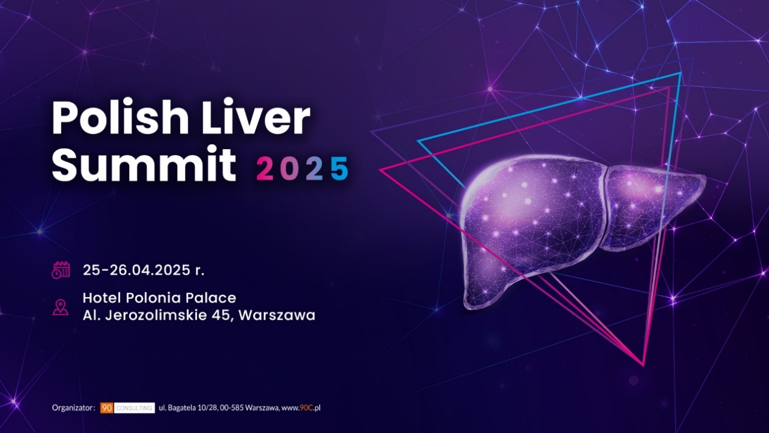
How far are we from WHO HCV Elimination 2030 goals with 10 years of revolutionary treatments?
Conference of Polish Hepatology Expert’s Group.
PRELIMINARY PROGRAM- Lecturers to be confirmed
25.04.2025
I: OPENING SESSION:
12:25-13:05 Purpose: Highlighting the actual status of Poland on HCV Elimination with a Multistakeholder approach with 6 Polish Stakeholders
Opening:
13:05-13:45 Polish perspective towards HCV elimination
13:45-14:00 10 Years of Revolutionary HCV Treatment
Status of HCV Elimination Globally & Poland National Elimination Profile - lecturer to be confirmed
II SESSION: Key Learnings on National Screening Programmes in EUROPE
14:00-14:20 Germany
14:20-14:35 Lithuania - National HCV Screening Program in Lithuania
14:35 -15:35 Introduction to debate: Status of Poland in GP Screening 2025
15:35–16:15 Debate Panel discussion: How Poland can improve elimination program?
16:15-16:30 COFFEE BREAK
III SESION: SCREENING STRATEGY FOR INTEGRATING HCV AS A MULTISYSTEMIC DISEASE in Europe
16:30-17:15 Purpose: Position Oncology and Emergency Screening strategies to be implemented for HCV Elimination in Hospitals
17:15-17:35 Spain
17:35-18:05 Debate Panel discussion: How can we unify our approach to accelerate elimination in Hospital Care System
IV SESSION: Key Learnings on HCV Elimination in Prisons in EUROPE
Purpose: Share UK and CZ Prison Programs and discuss how it can be applicable to Poland
18:05-18:20 HCV Management in Prison in UK and PWIDs
18:20-18:40 Prisoners Project - Czech
18:40-18:50 Achievements and Challenges in Prison
18:50-19:10 Debate Panel discussion: How can we accelerate elimination in Prisons?
V SESSION: ROLE of Patient Associations in HCV Elimination
19:10-19:20 Poland: Non-medical testing – good practice
19:20-19:30 Refuges in Poland
19:30-19:50 Closing

26.04.2025
MASLD and liver diseases diagnostics- 15-minute lectures
09:00-10:10 I Diagnostics of liver diseases
09:00-09:15 Is anti-HCV always relible in HCV infection identification
09:15-09:30 How to diagnose MASLD and MASH
09:30-09:45 Monitoring of liver cirrhosis – what to do to be aware of consequences
09:45-10:00 Liver biopsy versus/together with non-invasive tests
10:00-10:10 Discussion

10:10-11:20 II Rare/not diagnosed liver diseases
10:10-10:25 PBC – diagnostic and therapeutic perspective- Prof. Michał Kukla
10:25-10:40 HDV – shall we screen all HBV infected patients
10:40-10:55 HCC – how to avoid and treat
10:55-11:10 Hepatic encephalopathy – diagnosis and treatment at different stages of disease
11:10-11:20 Discussion

11:20-12:45 III MASLD
11:20-11:35 New nomenclature of steatotic liver disease – impact on everyday clinical practice
11:35-11:50 Risk groups of MASLD and how to screen them
11:50-12:05 Liver steatosis in Primary Care Settings
12:05-12:20 Do we have any treatment for MASLD
12:20-12:35 Future of MASLD specific therapy
12:35-12:45 Discussion

