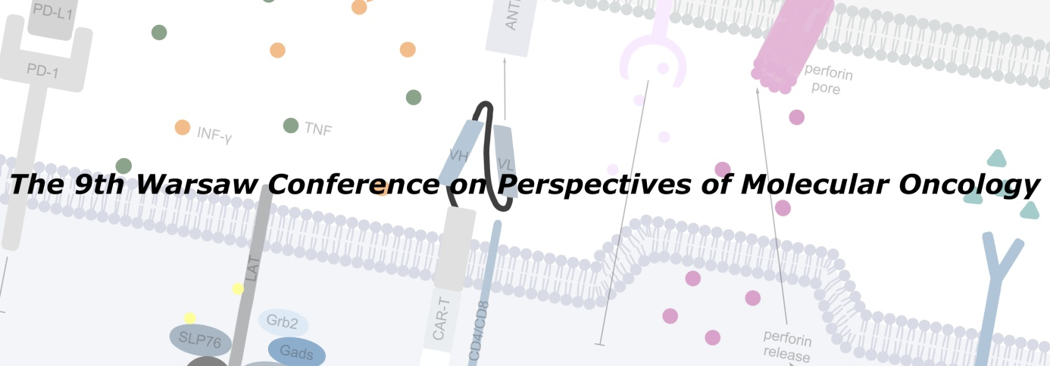

**The 9th Warsaw Conference on Perspectives of Molecular Oncology**

**September 12-13, 2024**

### ****12th September****

**8.30 -8:45** Welcome and opening – **Beata Jagielska and Michał Mikula**

**8.45 – 9.15** Opening plenary lecture:

Phenotypic Reprograming Overcomes Therapeutic Resistance in Advanced Prostate Cancer **Natasha Kiprianou** Icahn School of Medicine at Mount Sinai, [The Tisch Cancer Institute](https://scholars.mssm.edu/en/organisations/the-tisch-cancer-institute) NY USA

#### ****9.15 – 10.35 Session: translational research in prostate cancer****

**Chair: Teemu Murtola, Leszek Kotula**

**9.15 – 9.35** Targeting metabolic vulnerabilities of prostate cancer. **Teemu Murtola** Tampere University and Tampere University Hospital

**9.35 – 9.55** Learning tumor biology from prostate spatial transcriptomics analysis. **Alfonso Urbanucci** Tampere Univeristy

**9.55 - 10.15** Immune infiltrates and characterizing ongoing immunity in prostate cancer. **Ludvig Munthe** Oslo Univeristy Hospital

**10.15 - 10.35** Defining the transcriptional function of ABI1 in the context of prostate cancer. **Leszek Kotula** Upstate Medical University, USA

**10.35 – 10.50 coffee**

#### ****10.50 – 12.20 Session: Advanced immuotherapy and cancer immunity****

**Chair: Natalia Rusetska, Yulia Shvets**

**10.50 - 11.05** Human microbiome determines the effectiveness of cancer immunotherapy. **Yulia Shvets** Institute of Biology and Medicine, Kyiv National Shevchenko University

**11.05 – 11.25** Neutrophil-specific targeting of STAT3 impairs tumor progression via the expansion of cytotoxic CD8+ T cells. **Jadwiga Jabłońska** Essen University, Germany

**11.25 - 11.40** Immunomodulating activity of TGFBRI/TGFBRII receptor peptide inhibitors – molecular and clinical perspectives on the inhibition of TGF-β signalling pathways. **Jacek Plichta**, Medical University Łódź

**11.40 - 12.00** Dendtitic cell based immunotherapy in cancer patients: 10 years experience of the National Cancer Institute of Ukraine. **Natalia Khranovska** National Cancer Institute, Ukraine, Kyiv

#### ****12.00 - 12.20 sponsor lecture Roche****

**12.20 – 13.20 lunch**

#### ****13.20 - 14.55 Session: Translational research II – Chromatin, epigenetics and therapeutic targets****

**Chair: Tomasz Sarnowski, Alfonso Urbanucci**

**13.20 – 13.35** Taming the immunosuppressive tumor microenvironment with designer short peptides blocking SPP1-integrin interactions improves immunotherapy in glioma models. **Bożena Kamińska**, Necncki Institute Warsaw, Poland

**13.35 – 13.55** [Targeting ERBB3 and AKT to overcome adaptive resistance in EML4-ALK non-small cell lung cancer](https://www.researchsquare.com/article/rs-3919151/v1). **Richard Bayliss**, Leeds University UK

**13.55 – 14.15** Targeting the WASF3 regulatory complex in metastasis. **Eileen Kenedy**, University of Georigia, USA

**14.15 – 14.35** Identification of novel agents targeting BRD9 epigenetic reader combining computational and experimental approaches. **Gianluigi Lauro**, University of Salerno, Italy

**14.35 - 14.45 sponsor lecture Kawa-ska**

**14.45 - 15.00 Coffee**

#### ****15.00 – 16.05 Session: Translational research III -Metabolism and cancer****

**Chair: Piotr Młynarz, Ferdinando Chiaradonna**

**15.00 - 15.15** Exploring the Impact of the Astrocyte-Neuron Lactate Shuttle on Cognitive Decline in Aging: Insights from Metabolic Profiling. **Piotr Młynarz** Wrocław University of Technology, Poland

**15.15 - 15.35** Metabolic-based therapeutic strategies toward precision medicine for cancer. **Ferdinando Chiaradonna** Università degli Studi di Milano-Bicocca, Milan, Italy

**15.35 - 15.55** Metabolic targets in brain tumors. **Violaine Rosenstiel** DKFZ, Germany

#### ****15.55 - 16.05 - sponsor lecture Alab****

**16.05 - 16.20 coffee**

#### ****16.20 – 17.40 Session: Clinical research I – Immunotherapy of neoplasms of the immune system****

**Chair: Grzegorz Nowakowski, Jan Walewski**

**16.20 – 16.40** Bispecific CD20xCD3 antibodies (and anti-PD1) in lymphoma. **Wojciech Jurczak** NIO-PIB Kraków, Poland

**16.40 – 17.00** Can IMiDs improve immunochemotherapy of lymphoma? **Grzegorz Nowakowski**Mayo Clinic, USA

**17.00 – 17.20** Perspectives of treatment of lymphoma with genetically modified cells. **Marion Alcantara,** Curie Institute, Paris, France

**17.20 - 17.40 CAR-T in DLBCL and MCL treatment Jan Walewski, sponsor lecture Gilead**

**17.40- 18.30 poster session.**

### ****13th September****

#### ****8.30 – 9.25 Session: Clinical research II Immunotherapy of neoplasms of the immune system****

#### 

**Chair: Wojciech Jurczak, Marcin Kortylewski**

**8.30 - 8.45** Role of autologous and allogeneic hematopoietic cell transplantation in current treatment of lymphoma. **Joanna Romejko-Jarosinska** NIO-PIB

**8.45 - 9.05** Fine tuning of CAR-T cell response to lymphoma. **Jan Walewski** NIO-PIB

**9.05 - 9.25** Targeted oligonucleotide strategies for cancer immunotherapy. **Marcin Kortylewski** City of Hope, LA USA

#### ****9.25 – 10.35 Session: Translational research IV Extracellular vesicles in Oncology****

**Chair: Piotr Widłak, Monika Pietrowska**

**9.25 - 9.55** Blood vessel regulating ‘nanosphere’ in cancer – vasectasia and beyond. **Janusz Rak** McGill University, Montreal, Canada

**9.55 - 10.10** Is HPV genomic DNA present in small extracellular vesicles? **Monika Pietrowska**NIO-PIB, Gliwice

**10.10 - 10.20** Cancer signature in lymphocyte-derived exosomes circulating in the plasma of melanoma patients. **Piotr Widłak** Medical University of Gdańsk

**10.20 - 10.35** Proteomic and metabolomic signatures of rectal tumor discriminate patients with different responses to preoperative radiotherapy. **Anna Wojakowska** Institute of Bioorganic Chemistry, Poznań

#### ****10.35 - 10.55 sponsor lecture BRUKER****

**10.55 – 11.10 coffee**

#### ****11.10 – 12.25 Session: Translational research V – new point of view****

**Chair: Damian Gaweł, Michał Mikula**

**11.10 - 11.25** Cubosomes – a promising drug delivery system in cancer therapy. **Damian Gaweł**CMKP

**11.25 - 11.40** Regulation of polymerase iota - the most error-prone human DNA polymerase **Justyna McIntyre** IBB PAS Warsaw

**11.40 - 11. 50**Patient-derived tumor models - are we ready for the avatar-guided personalized cancer treatment?**Michał Mikula** NIO-PIB

**11.50 – 12.05** Molecular classification of somatotroph pituitary tumors. **Mateusz Bujko**NIO-PIB

**12.05 - 12.20** Non-catalytic subunits of the replisome - genetic stability and cell cycle control. **Michał Dmowski** IBB PAS

#### ****12.20 - 12.25 sponsor lecture CeGaT GmbH****

#### ****12.25 – 13.15 Session: young investigators session: presentation of the best research and poster ( 3 best abstracts from conference (3x 10 min), 2x10 min the young investigators)****

#### ****Chair: Małgorzata Stachowiak, Daniel Bajerski****

**13.15– 14.00 lunch**

#### ****14.00 - 15.05 Session: Clinical research and pathology****

**Chair: Szymon Piątek, Monika Durzyńska**

**14.00 - 14.15** Is it possible to detect the loss of efficacy of PARP inhibitors in ovarian cancer before clinical and radiological progression? **Szymon Piątek** NIO-PIB

**14.15 - 14.30**Diagnostic pathology- from bsic histology to molecular profiling **Andrzej Mróz** NIO-PIB

**14.30 - 14.45** The role of pathologist in tumor agnostic therapy. **Monika Durzyńska** NIO-PIB

**14.45 - 15.05 What does PD-L1 positive or negative mean in various tumors? Wojciech Olszewski MSD sponsor lecture**

**15.05 - 15.20 coffee**

#### ****15.20 - 16.20 Clinical and molecular research – what we can learn together?****

**Chair: Ludvig Munthe, Małgorzata Oczko - Wojciechowska**

**15.20 - 15.35**Host genetic variation as a determinant of cancer outcomes. **Dorota Butkiewicz** NIO-PIB Gliwice

**15.35 - 15.45** Early prediction of relapse in clear cell renal cell carcinoma (ccRCC). **Maciej Łuba** NIO-PIB

**15.45 - 15.55** Immunomodulatory effect on CD4 T cells by cabozantinib. **Piotr Domański** NIO-PIB

**15.55 - 16.10**Renal cancer-expressed amphiregulin reprograms transcriptome of mesenchymal stromal cells and promotes their tumor recruitment in vivo. **Agnieszka Piekiełko-Witkowska** CMKP Warsaw

#### ****16.10 - 16.20 sponsor lecture Pro-Environment****

**16.20- 16.50 closing lecture**

Chair: **Ludvig Munthe**

Why does immunotherapy fail so often? **Polly Matzinger, NCI Bethesda, USA**

16.50 – closing remarks